Issue | Priority
- Share-class-expansion plus icon overlapping with fund name  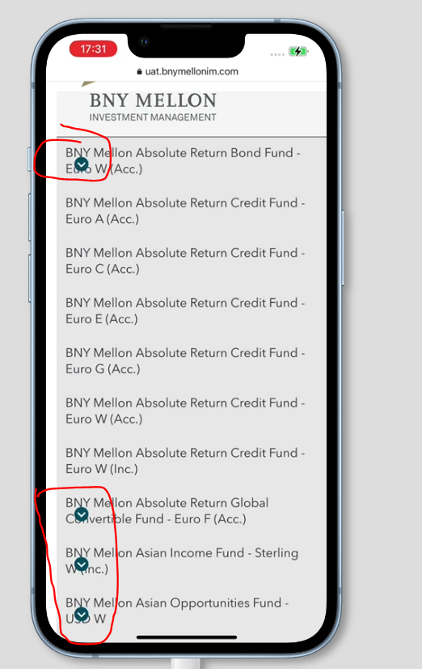 | Medium – not happening on all device resolutions but needs resolving.
- Extra space present near All fund and prices  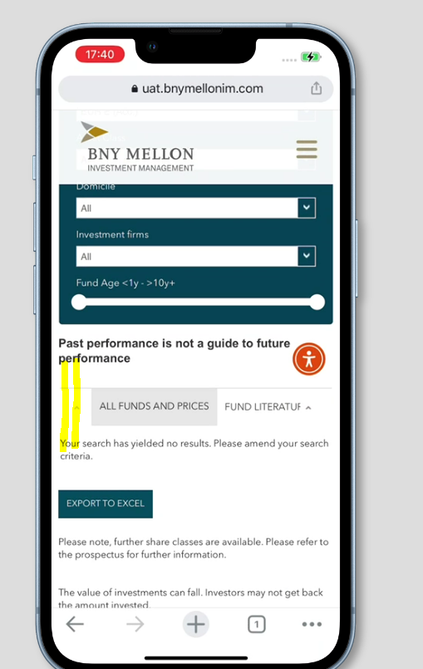 | Medium
- Document and PDF icons overlapping text on all tabs – All funds & prices, Fund literature, Regulatory literature and Sustainability related disclosures:  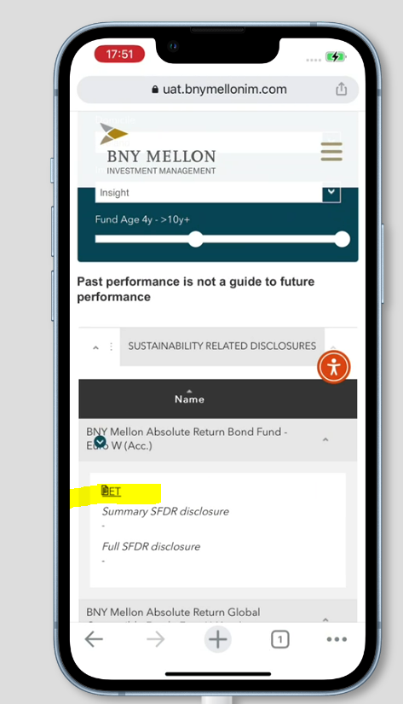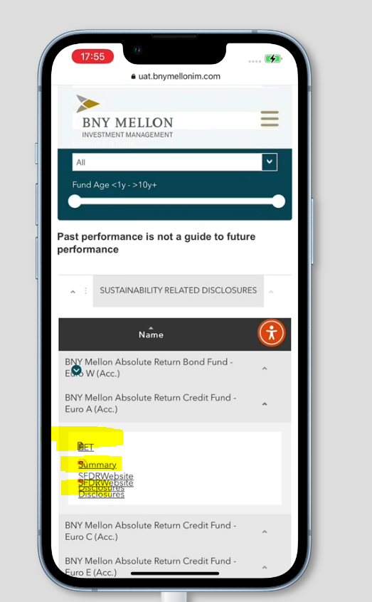  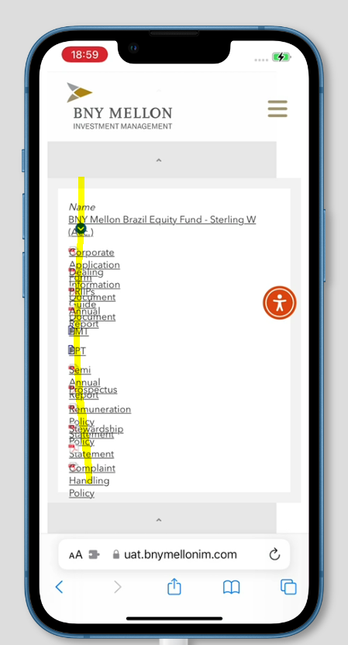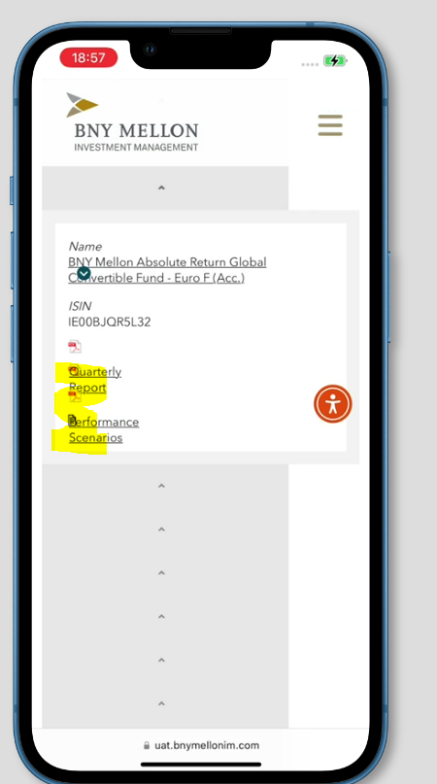  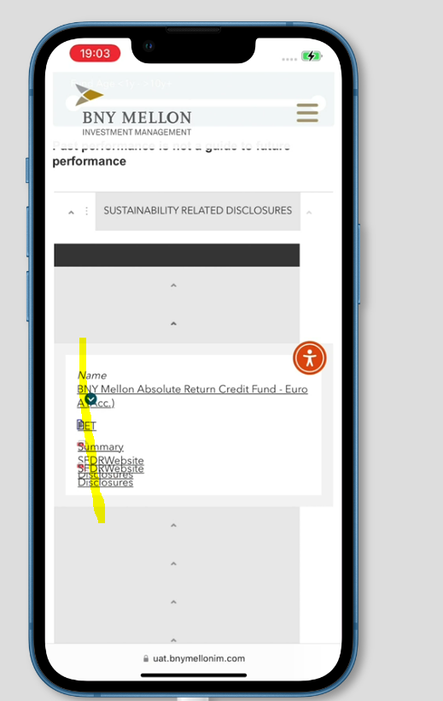 | High
- Export to excel - > continue and cancel buttons not displayed  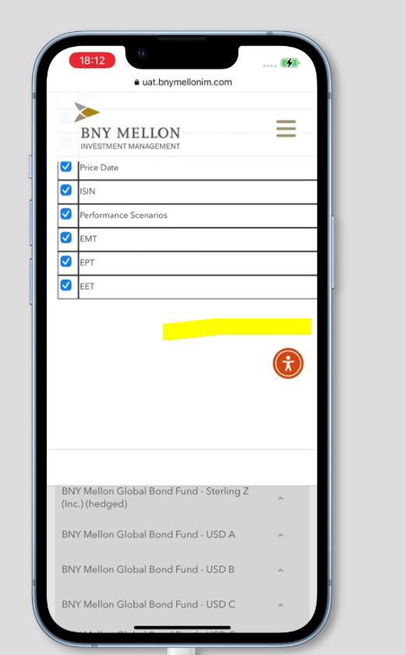 | High – cannot scroll to even see it on the right or close the box. It also appears at the top of the screen, so if you click on the button (which is at the bottom of the table), it seems like nothing has happened – you only see the pop-up if you scroll back up the page to find it. Non-project team users will not know this and will completely miss it and think the function is broken.
- Download icon and text are not displayed in the same line in the additional SFDR document links box (AEM issue)  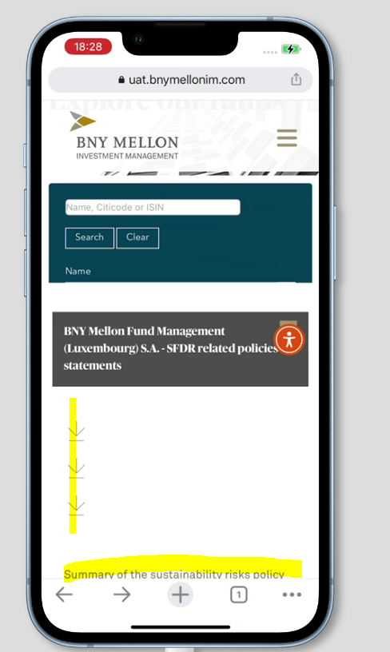 | Med - To be raised by BNYM with AEM team
- All funds & prices tab - Investment manager logo size is not proper and document name ,icon and download tool overlapping  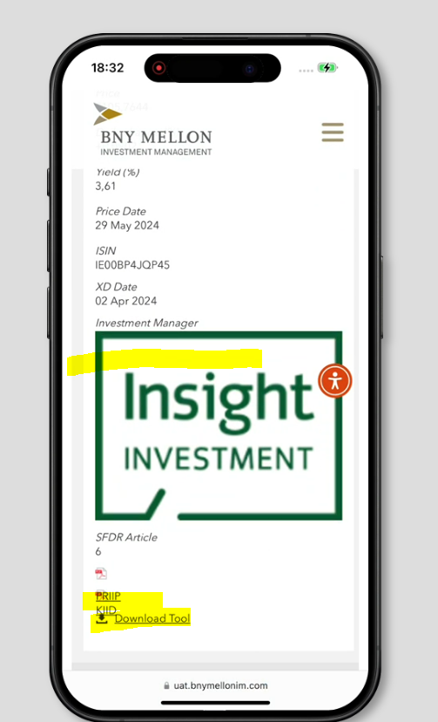 | Med – logo  High – icons & docs overlapping
- Fund names not displayed - this happens in portrait on some sites but also on al sites if you go from portrait to landscape orientation of the mobile device.  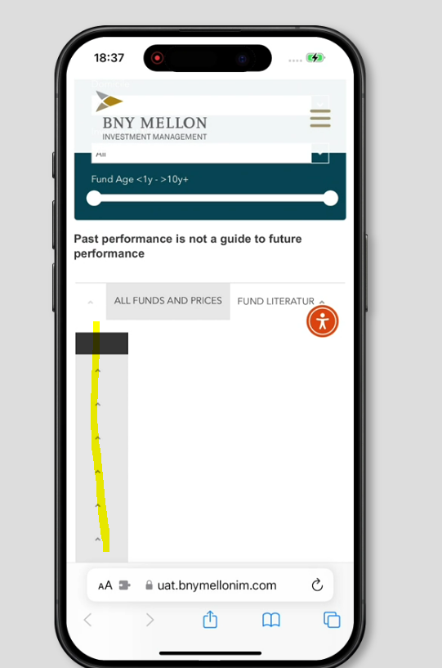 | High – this happens when you expand one of the funds – initially the whole list appears but when you expand a single fund the fund names in the whole list disappear.
- Download price tool - Select a fund, Select a time period dropdown, from & to date input box, display on screen button and downlaod csv button - not displayed properly.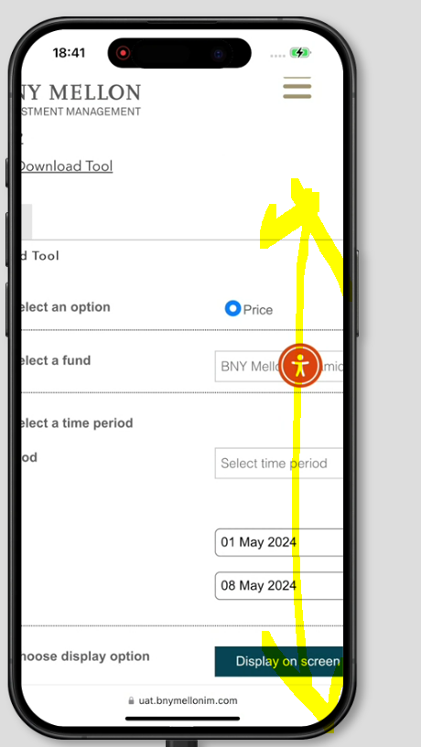 | High
- Download price tool - Price date column not displayed and close button not displayed  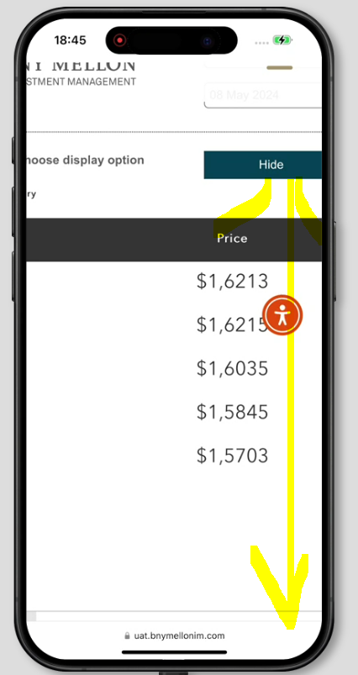 | High
- Select fund literature and expand any fund: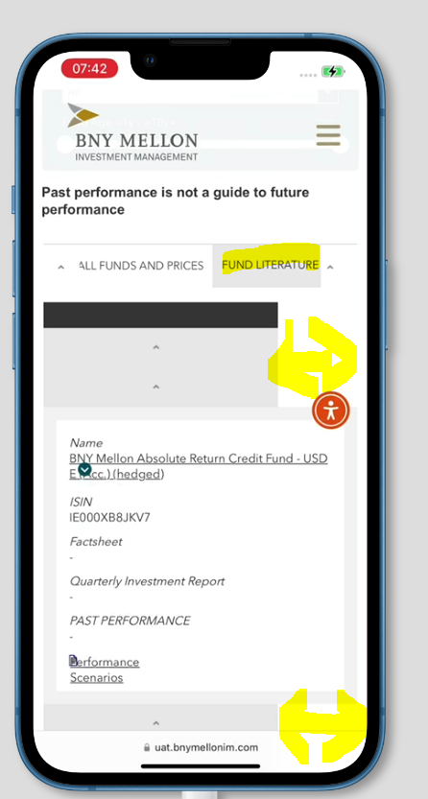 | Med
- Not able to scroll vertically or horizontally on fund tables or HTML fund pages  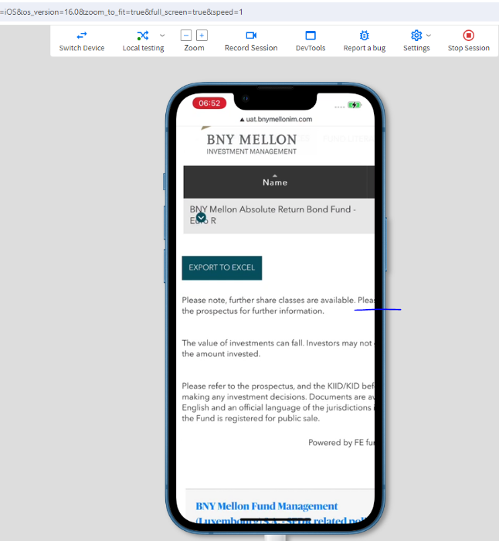 | High
- After clicking the arrow to view fund details, the page looks like this afterwards:  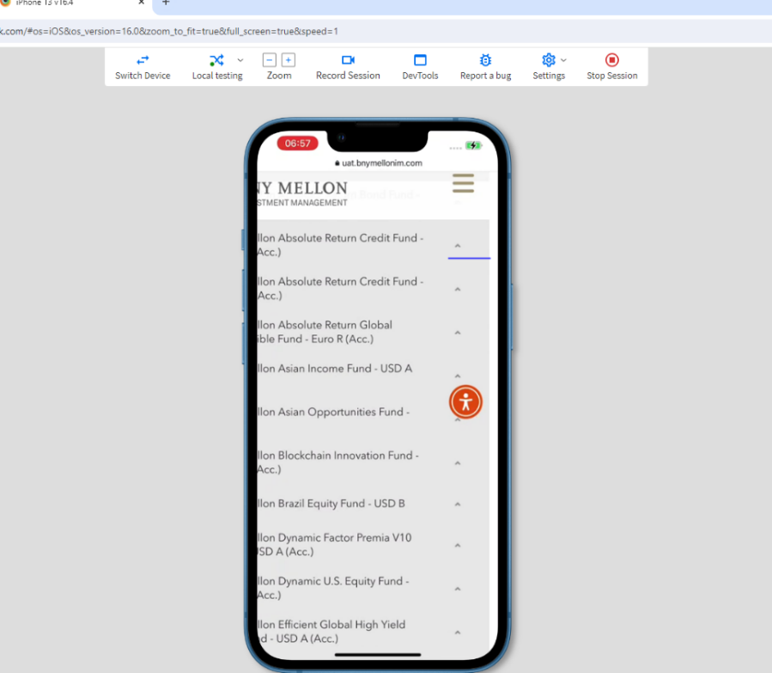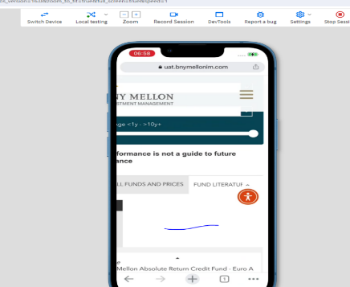  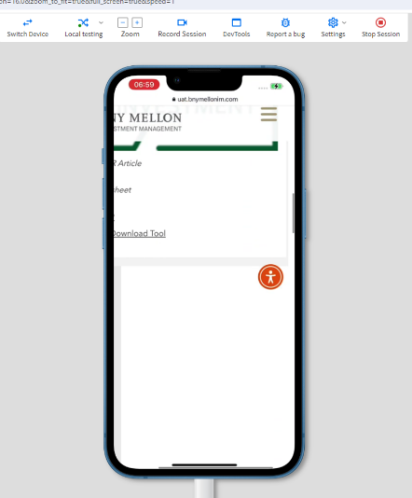 | Med
23. fund name not getting display only expansion icon displayed. See: https://uat.bnymellonim.com/at/de/institutional/funds-centre/  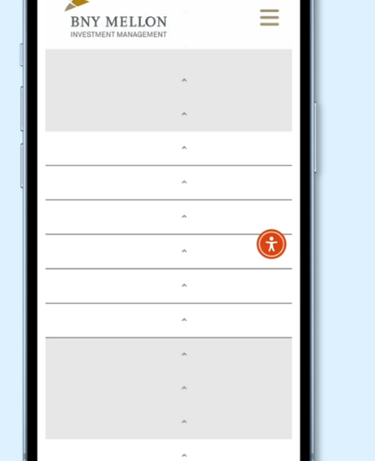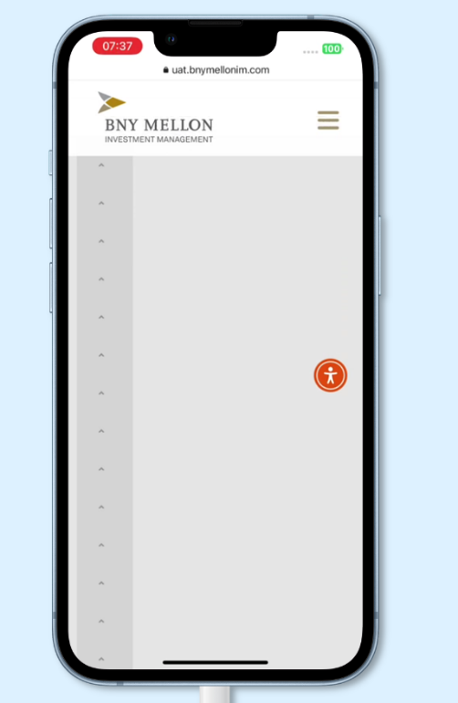 | High

